Datapower Kubernetes

Refer to IBM site:

<https://developer.ibm.com/datapower/docker/>

$docker pull ibmcom/datapower

$docker images

$docker run –it –v $PWD/config:/drouter/config \

-v $PWD/local:/drouter/local \

-e DATAPOWER_ACCEPT_LICENSE=true \

-e DATAPOWER_INTERACTIVE=true \

-p 9090:9090

--name idg ibmcom/datapower

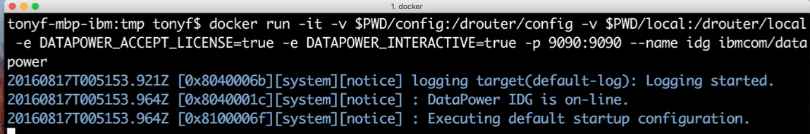

User /pass: admin/admin

Idg#con

#web-mgmt 0 9090 9090